Part I

Part I : Nearest Neighbor, Nearest Neighbor 2-Opt, Repeated Randomness, Nearest Neighbor
The algorithms implemented in this section do not find optimal paths to solve the TSP. The basic NN algorithm is a greedy heuristic that makes locally optimal choices by always selecting the nearest unvisited city, failing to consider global problem structure. While 2-Opt refinement improves solutions by eliminating edge crossings through local swaps, it cannot escape local optima to reach the global optimum. These locally-focused strategies fundamentally limit solution quality compared to exhaustive search methods like A*.
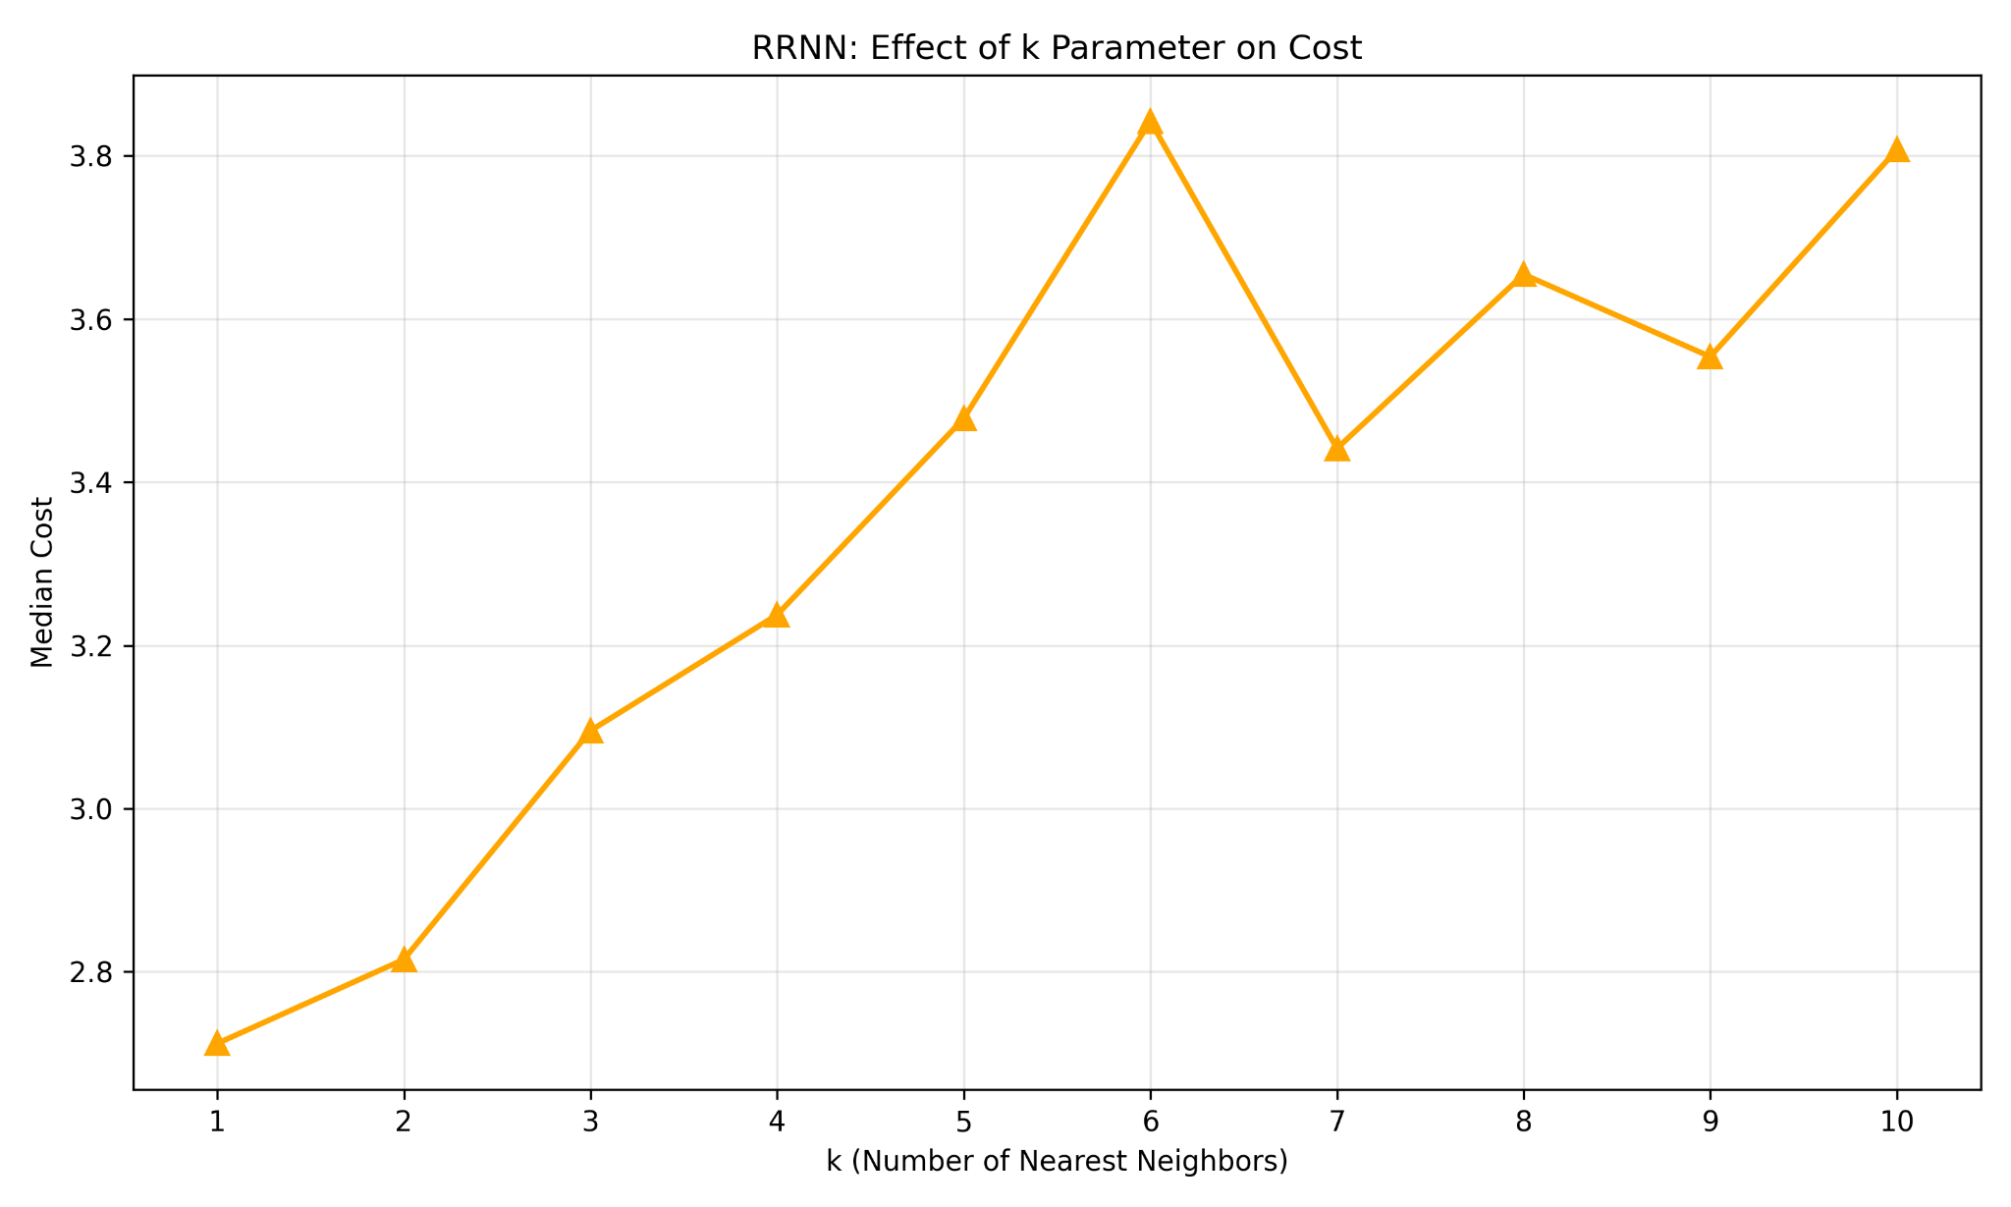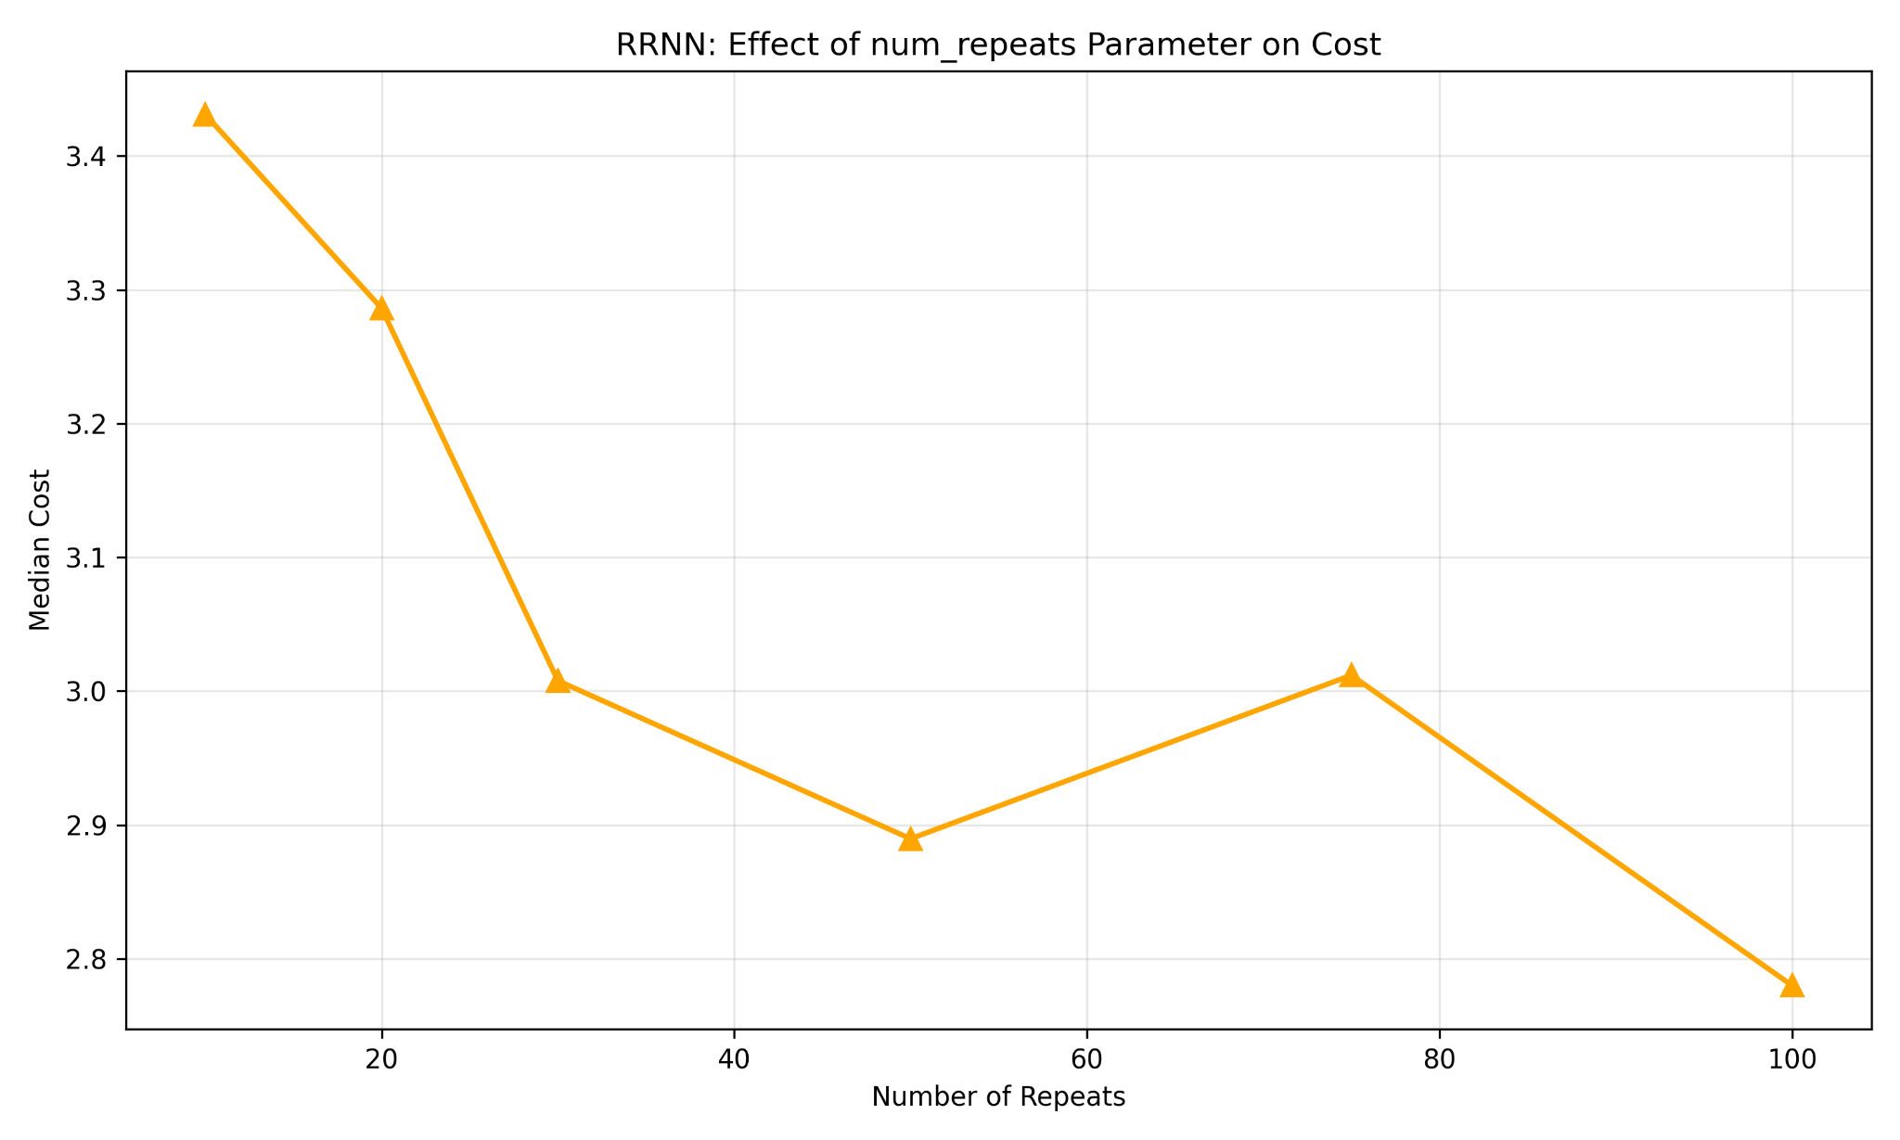
For the RRNN algorithm, k=3 was chosen as optimal. The k parameter plot shows median cost initially increasing from k=1 to around k=6, peaking near 3.8-3.9, before showing high variability at larger values. At k=1, the algorithm behaves identically to deterministic NN with no randomness benefit. The sweet spot around k=4 provides meaningful exploration by choosing from multiple reasonable next cities without introducing excessive randomness. Beyond k=6, costs become erratic, suggesting that too many neighbor choices allow selection of suboptimal distant cities that degrade tour quality. The tradeoff balances exploration diversity against solution quality. Smaller k values provide insufficient randomness, while excessively large k values degrade initial tours.
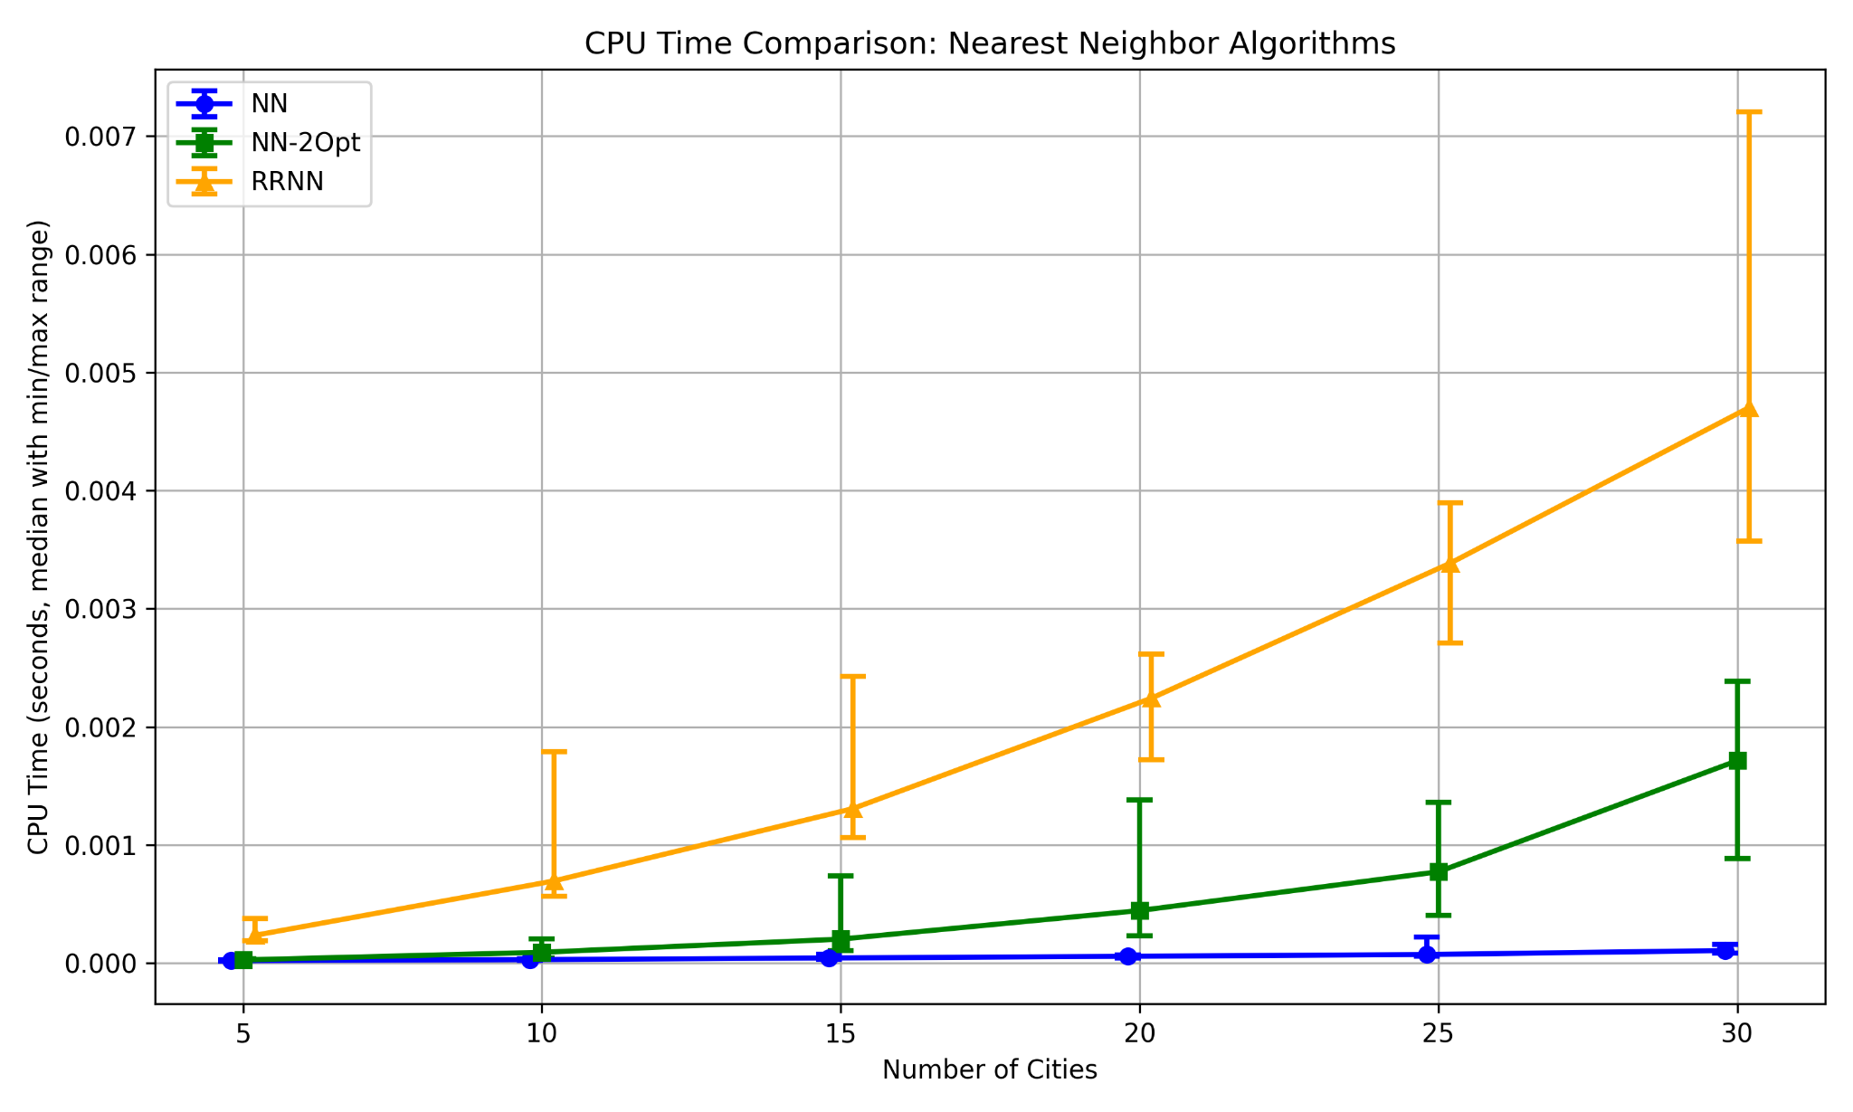
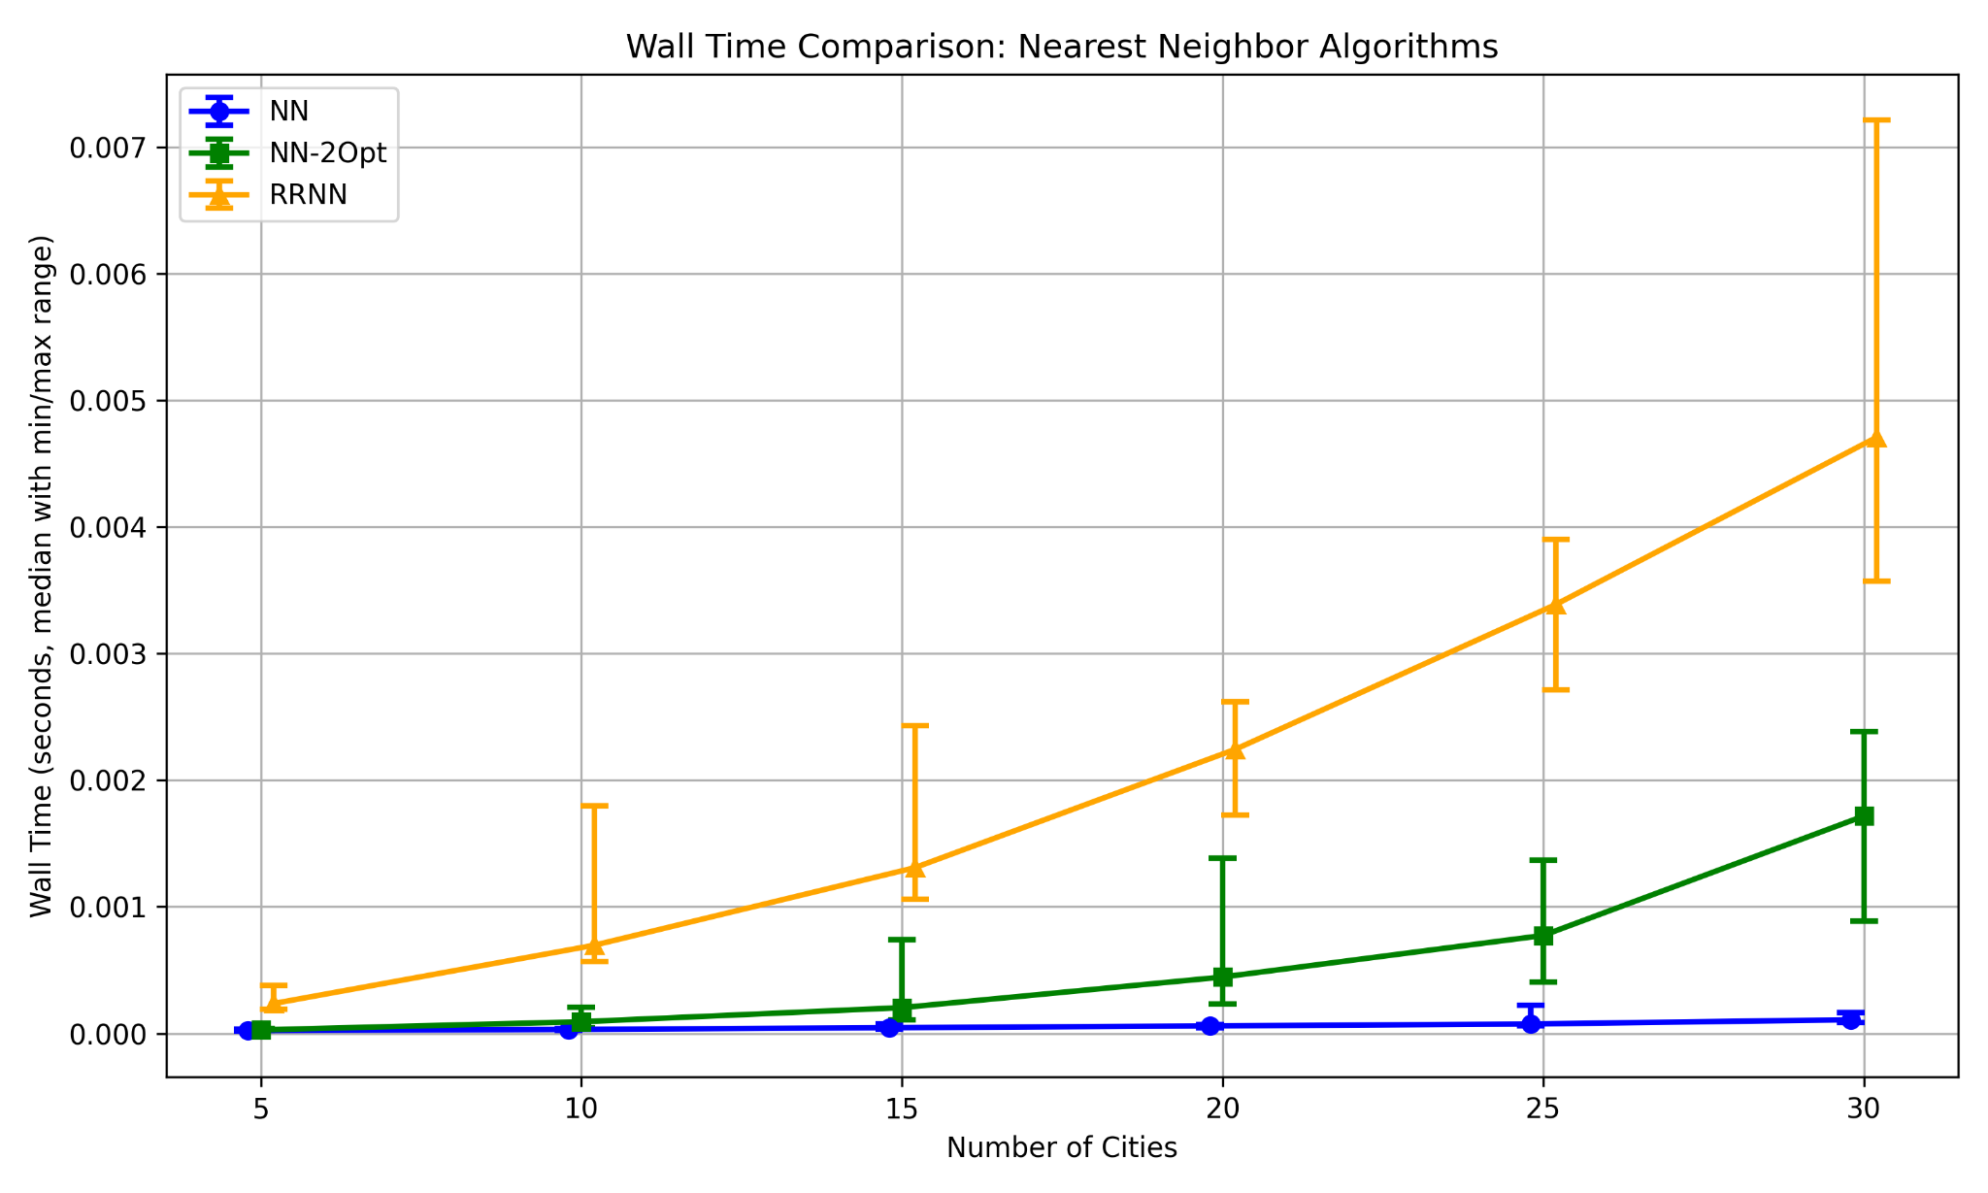
The num_repeats parameter was set to 30 based on convergence analysis. The tuning curve shows dramatic improvement from 10 to 50 repeats, with median cost dropping from approximately 3.45 to 2.88. This steep descent indicates early iterations discover significantly better solution space regions. Beyond 50 repeats, improvement continues gradually to 2.78 at 100 repeats, representing diminishing returns. The value 50 captures most benefits while avoiding doubled computational cost for marginal gains. The tradeoff balances solution reliability against computation. Fewer repeats provide insufficient sampling and high variance, while values beyond 50-80 show diminishing returns per additional restart.
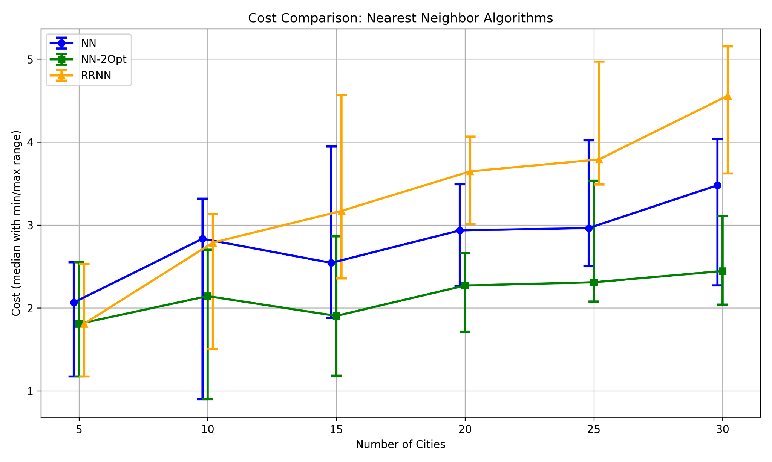
NN found solutions quickest across all problem sizes. Both time plots show NN maintaining nearly flat performance, requiring minimal time even as cities increase from 5 to 30. This speed advantage comes at significant accuracy cost. The cost comparison shows NN producing highly variable tours ranging from 1.5 to 3.5 in median cost with substantial error bars. NN-2Opt demonstrates middle ground performance, with times remaining under 0.002 seconds at 30 cities while dramatically improving solution quality to the 1.8-2.5 cost range with tighter variance. RRNN exhibits the highest computational cost, reaching approximately 0.005-0.007 seconds at 30 cities roughly 3-4 times slower than NN-2Opt. However, this investment yields the best solution quality, with median costs in the 1.8-3.8 range and achieving some of the lowest tour lengths observed.
The time complexities directly explain observed patterns. Basic NN operates in O(n²) time, examining all remaining cities at each step. This quadratic growth is barely visible because constant factors are small. NN-2Opt adds refinement complexity of O(n²) per iteration, with the number of iterations typically bounded, yielding effective O(n² log n) complexity. This explains the gentle upward curve in time plots. RRNN multiplies NN-2Opt complexity by num_repeats (30), resulting in O(n²) with a 30x constant factor. This manifests clearly where RRNN curves sit substantially higher while maintaining similar growth rates. The cost comparison shows the quality payoff. RRNN's multiple restarts explore different solution space regions, occasionally finding significantly better tours than deterministic approaches.

Part II

Part II : A* with MST Heuristic
The A* implementation represents solutions as partial tours or ordered sequences of visited cities. Each state encodes which cities have been visited and their visitation order. This representation required efficient data structures for tracking visited cities (sets for O(1) lookup) and maintaining priority queues ordered by f(n) = g(n) + h(n). The MST heuristic calculation necessitated integrating a minimum spanning tree algorithm to compute lower bound costs for completing tours from any partial state. This representation enabled clear separation between search logic, state management, and heuristic computation, though it introduced memory overhead for storing potentially exponential numbers of partial tour states.
The algorithm became unable to run reliably beyond 10 cities within reasonable time constraints. The primary bottleneck is exponential growth in nodes that must be expanded. While the MST heuristic prunes many unpromising branches, worst-case search space remains O(n!) for complete enumeration. The nodes expanded plot demonstrates this explosive growth, increasing from single digits at n=5 to potentially hundreds at n=10. The heuristic computation itself must be performed for every expanded node, creating a multiplicative effect. Improvements could include implementing more sophisticated pruning strategies, using tighter heuristic bounds, or employing iterative deepening with increasing cost thresholds.
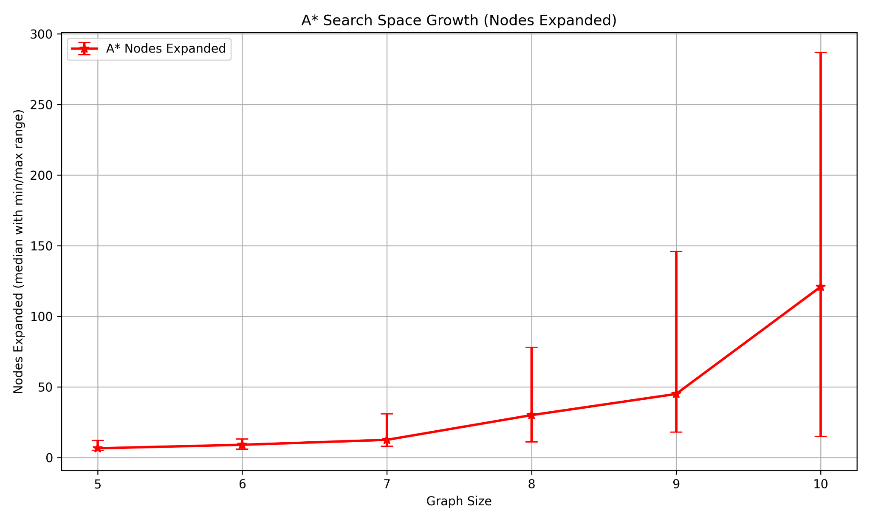
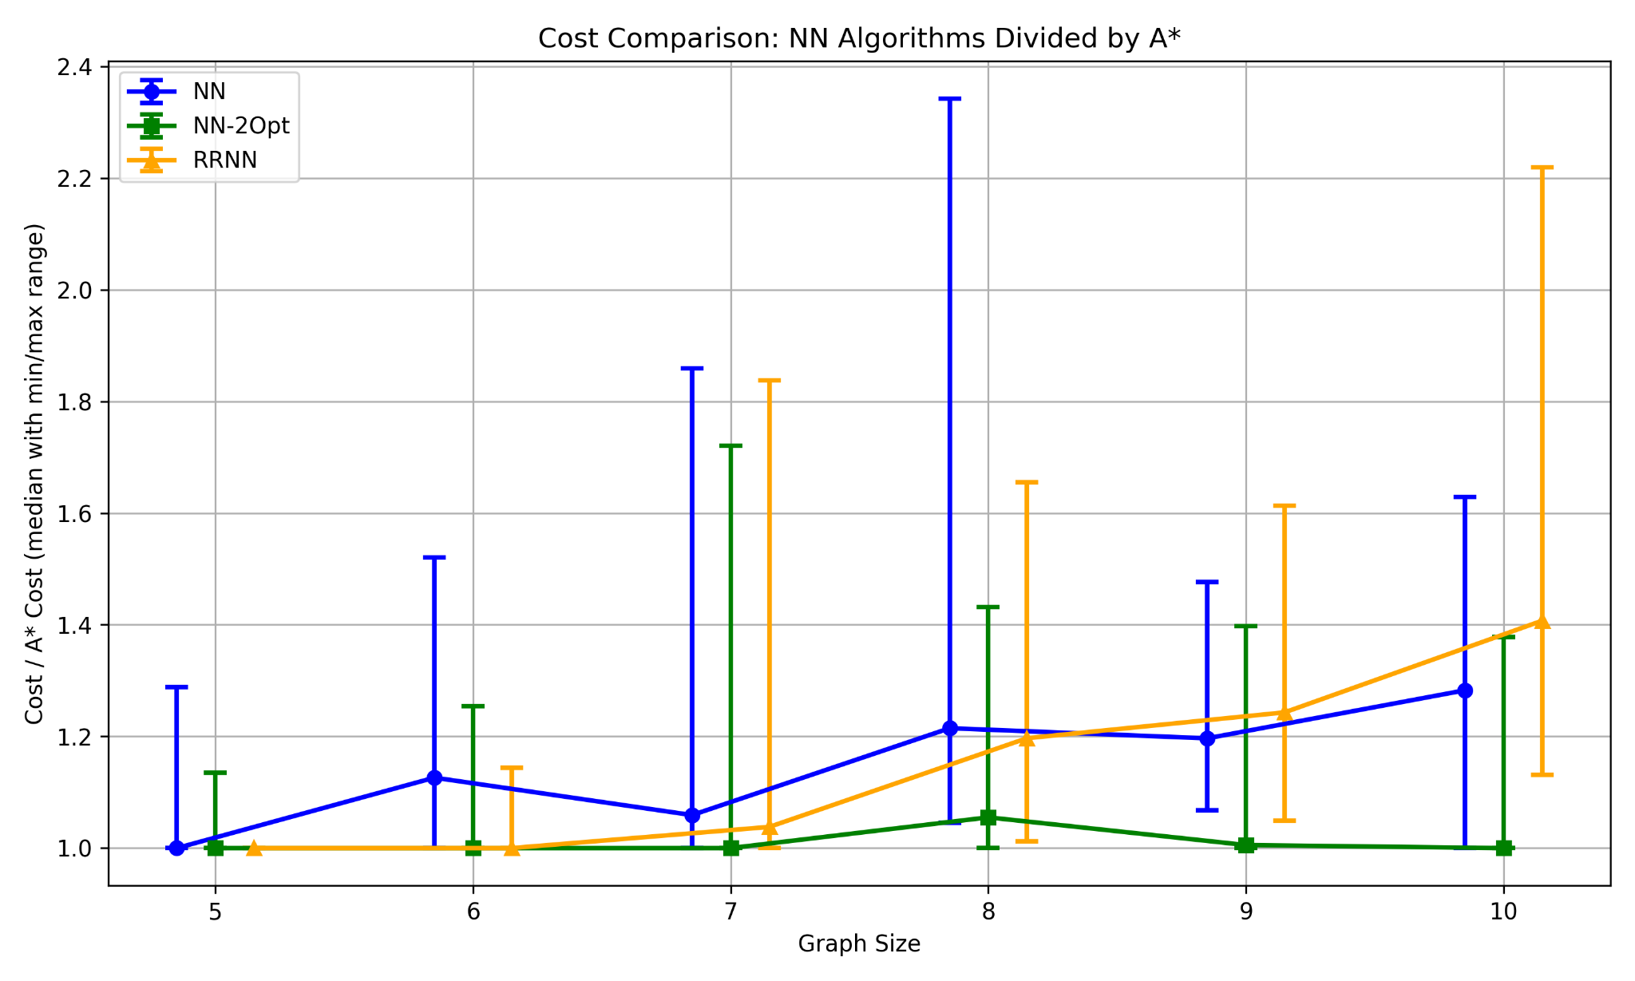
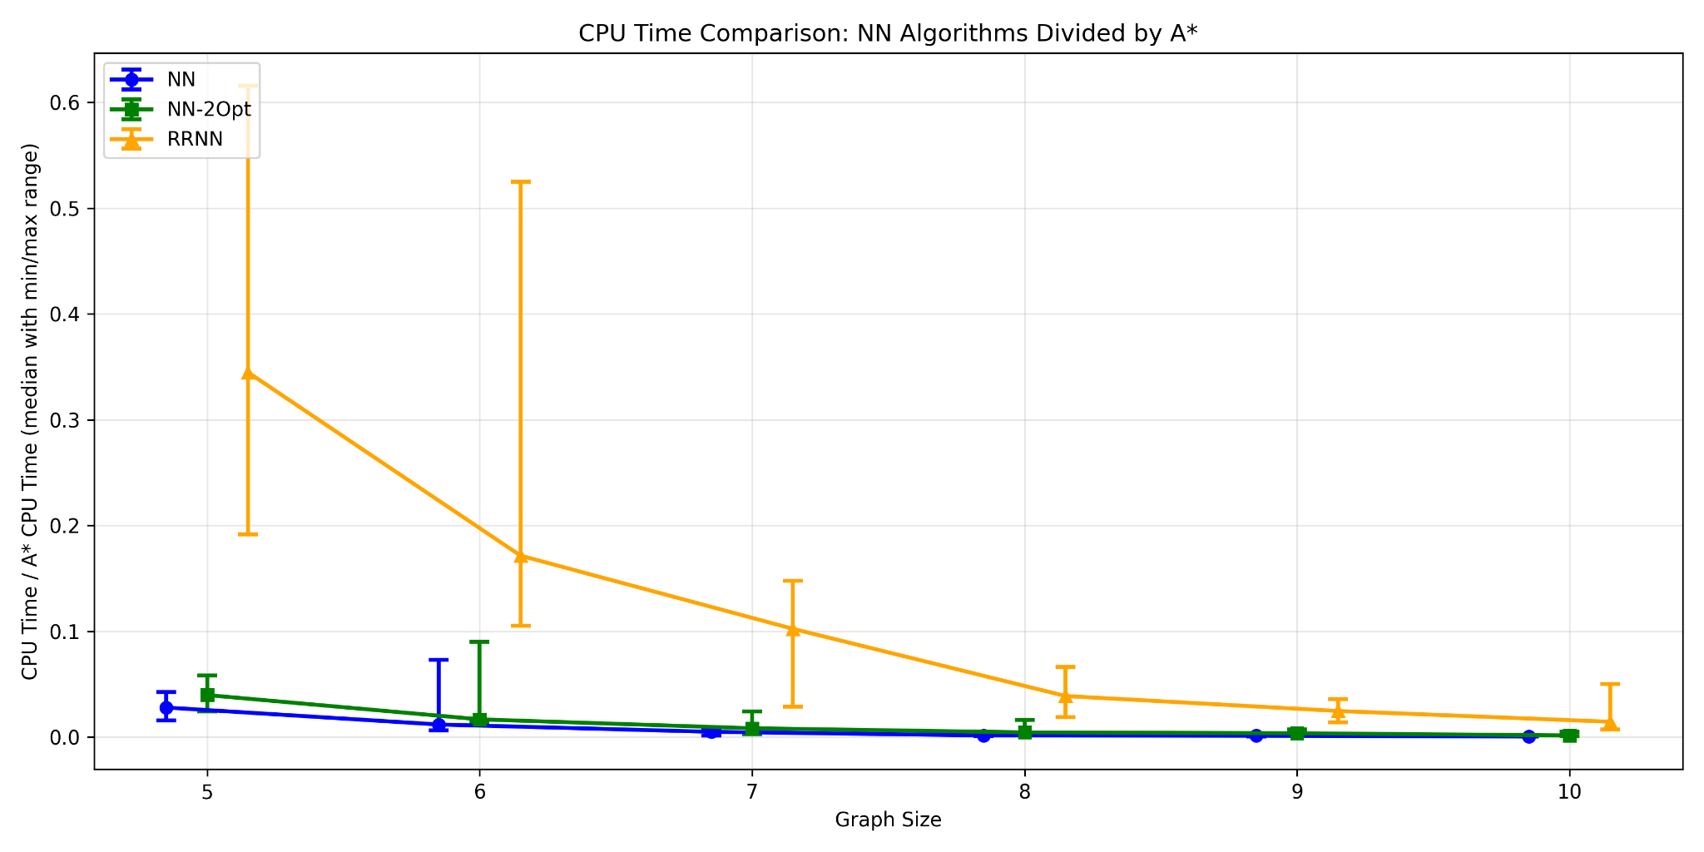
The exponential increase in nodes expanded directly correlates with runtime limitations. As graph size grows from 5 to 10 cities, expanded nodes increase by roughly 10-20x between successive problem sizes in later stages. This growth reflects the factorial nature of TSP solution space, where each additional city multiplies possible tours by approximately n. The MST heuristic provides admissible guidance that reduces this from theoretical maximum but cannot overcome fundamental combinatorial explosion. Variance in expanded nodes indicates problem structure matters significantly. Some city configurations allow more aggressive pruning, but the overall trend remains clearly exponential.

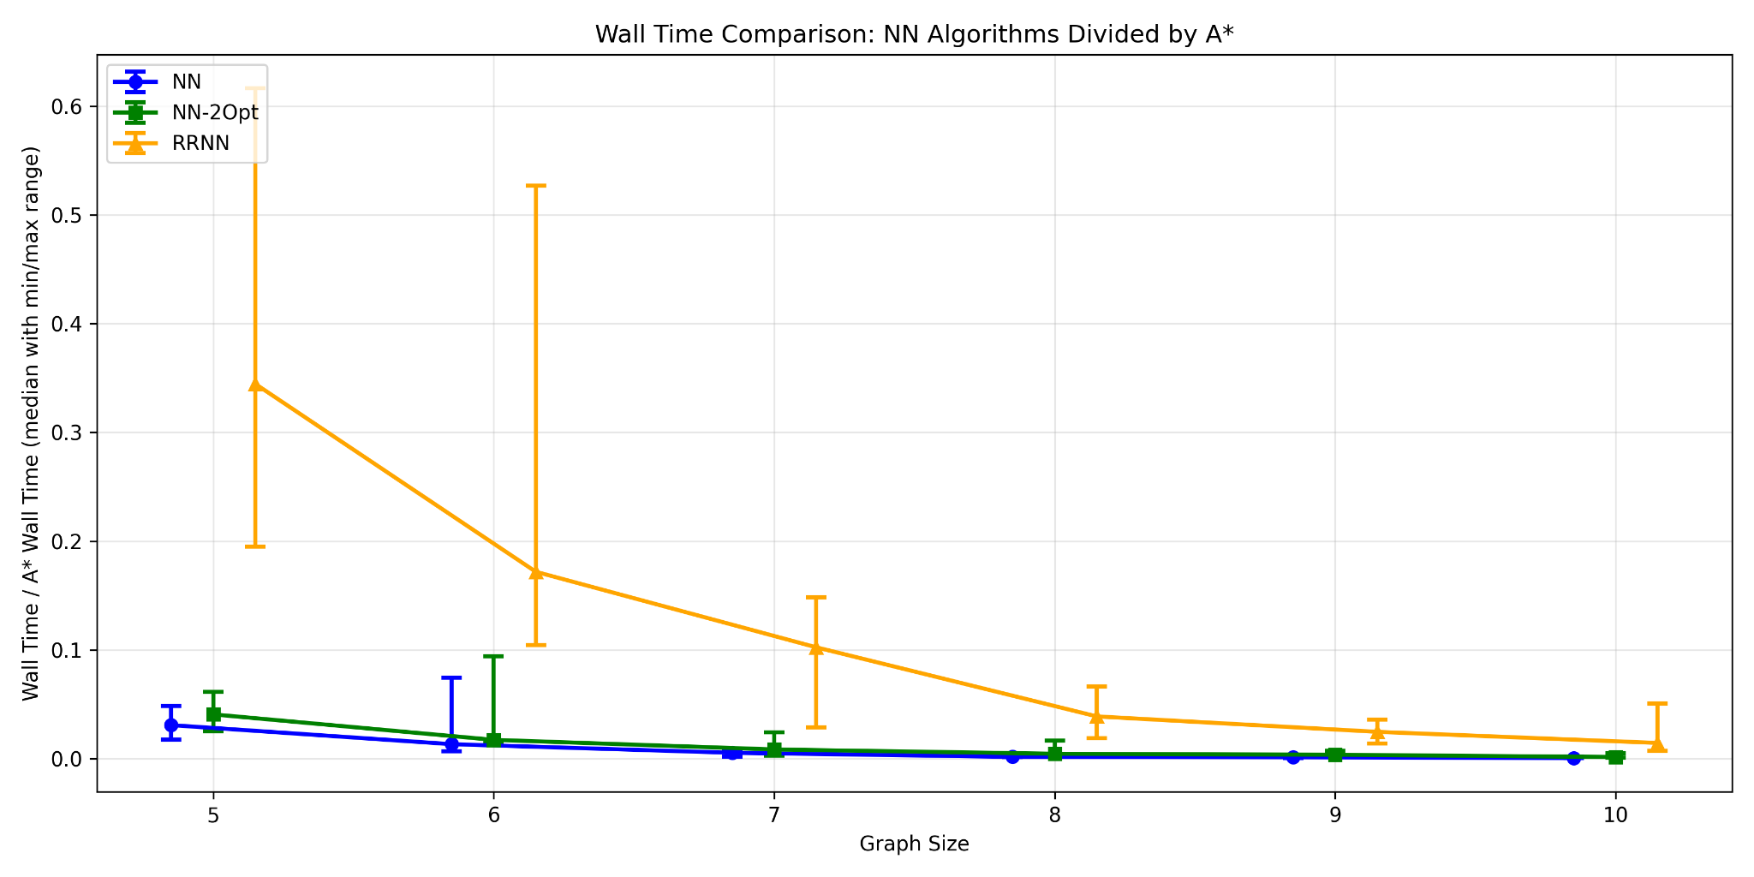
Compared to other algorithms, A* achieves perfect solution quality, always finding optimal tours. However, this optimality comes at severe computational cost. Wall time comparison shows A* requiring orders of magnitude more time than any nearest neighbor variant for problems with 7 or more cities. While NN algorithms complete in milliseconds even for 30-city problems, A* struggles with 10 cities. For real-world use, A* remains impractical except for small TSP instances (fewer than 12-15 cities) where optimality is absolutely required and computational resources are available. Industries requiring provably optimal solutions for small routing problems such as precision manufacturing tool paths or small-scale delivery optimization might justify A*'s computational cost. For larger practical problems, heuristic algorithms provide acceptable near-optimal solutions in reasonable time frames.

Part III

Part III: Hill Climbing, Simulated Annealing, Genetic Algorithms
These three algorithms represent solutions as complete tours or permutations of city visitation orders. The concept of a "neighbor" differs slightly for each but shares the principle of small perturbations. For Hill Climbing and Simulated Annealing, a neighbor is generated by randomly swapping two cities' positions, creating a solution in the immediate vicinity in solution space. The Genetic Algorithm employs a more sophisticated notion through crossover operations combining parent tours and mutation operations randomly swapping cities, allowing both local and more distant exploration.
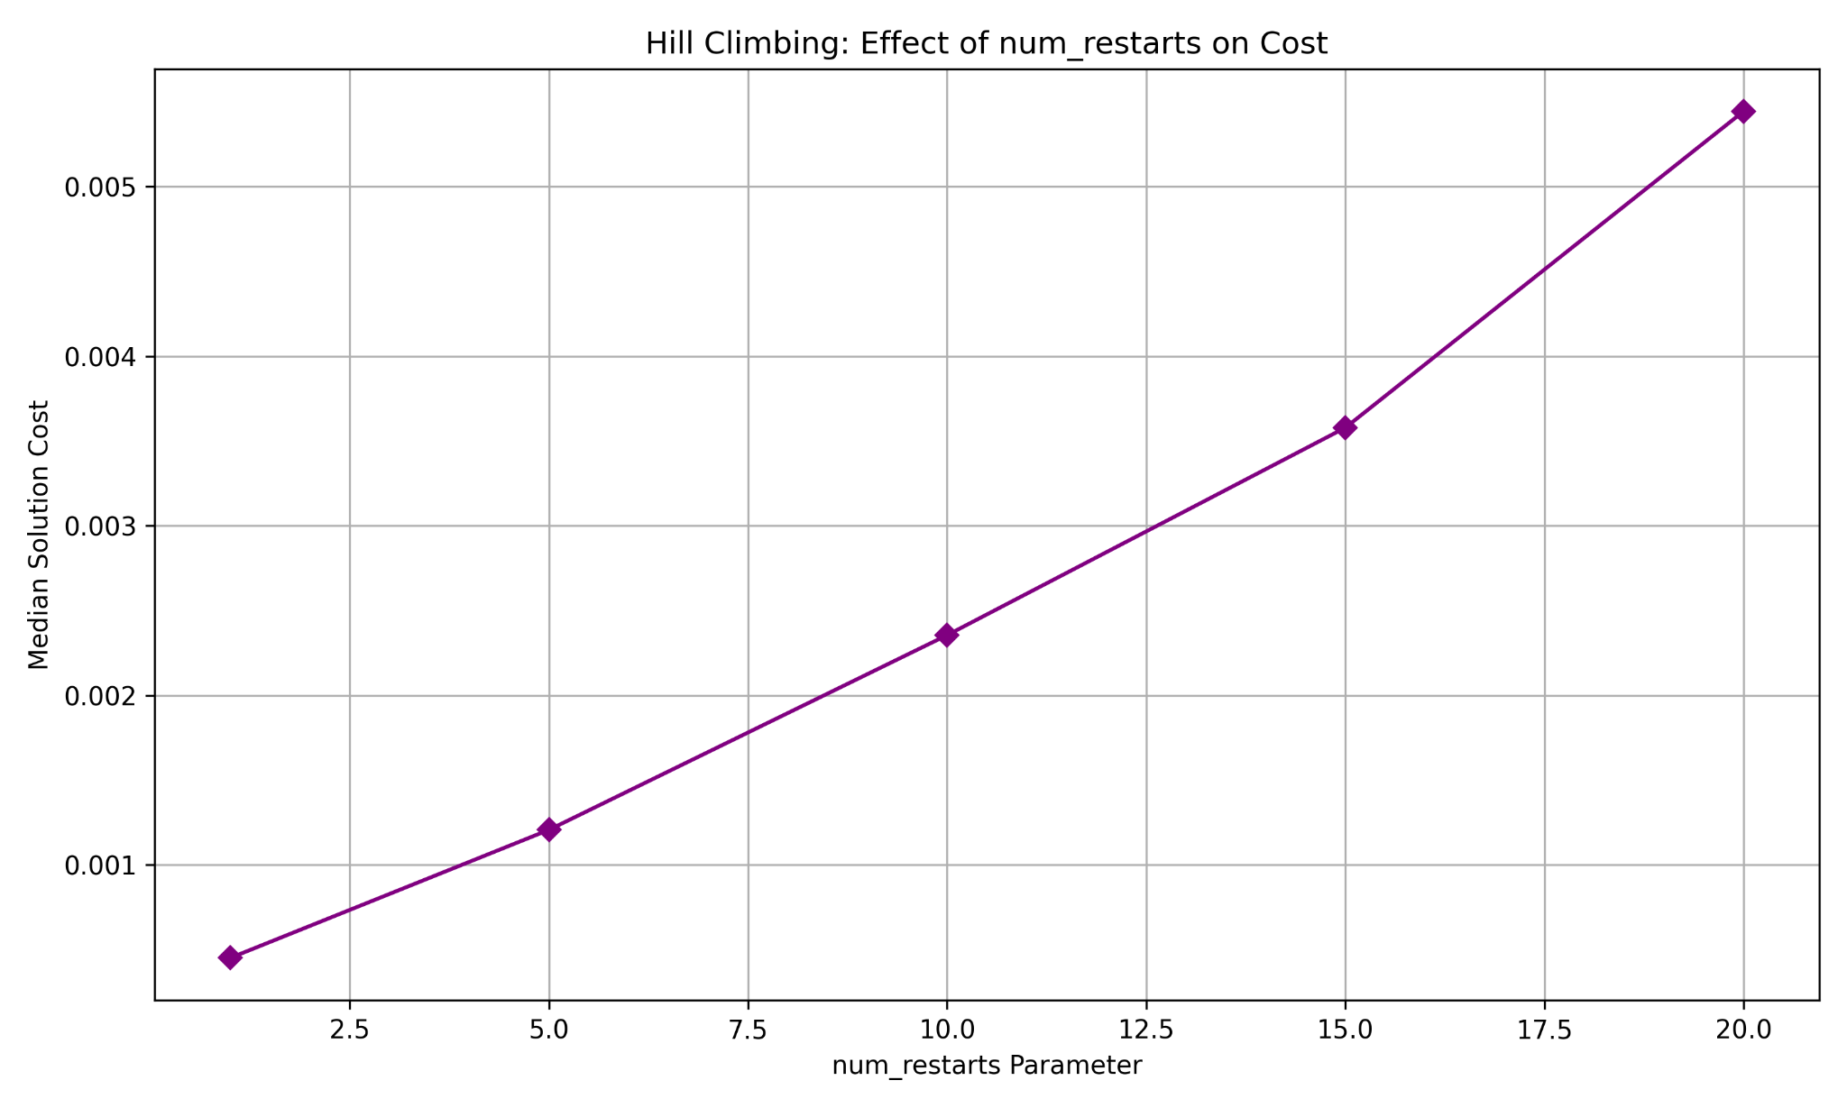
For Hill Climbing, num_restarts = 10 was optimal. The hyperparameter tuning plot shows solution quality improving steadily as restarts increase from 1 to approximately 10, after which gains become marginal while cost continues growing linearly. Lower values like 1-5 leave the algorithm vulnerable to poor initial solutions and early local minima trapping. Higher values beyond 15-20 provide diminishing returns, finding marginally better solutions at significant time cost. The tradeoff balances computational budget against solution reliability. More restarts increase probability of starting near good solution space regions, but each restart requires complete hill climbing search.

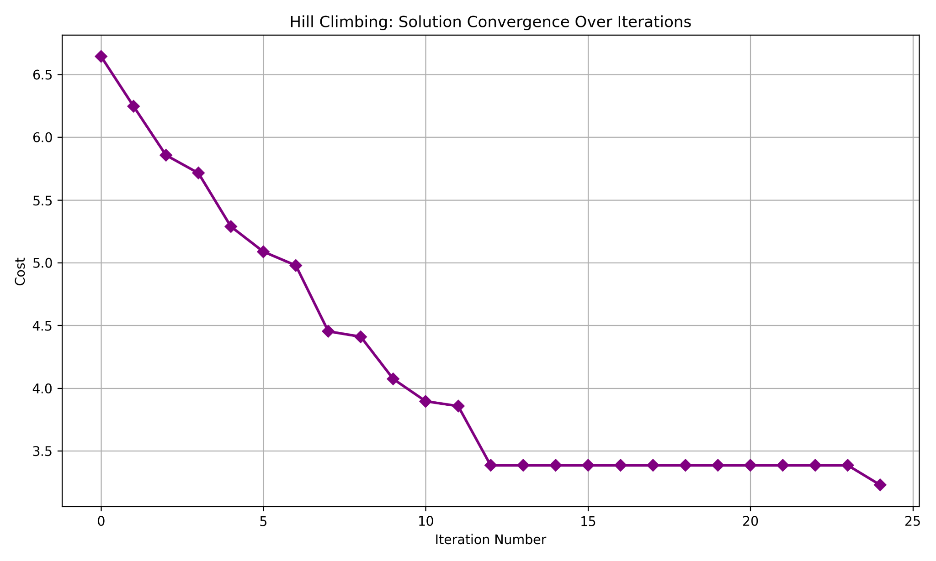
The Hill Climbing convergence plot demonstrates characteristic rapid initial improvement followed by plateaus. Starting from a random high-cost tour, the algorithm quickly descends to a local optimum within 2-3 iterations as it greedily accepts all improving swaps. Subsequent iterations show minimal improvement with high variance, indicating the algorithm has reached a local minimum and subsequent restarts explore different solution space regions. Some restarts find better local optima than others, explaining periodic cost drops in later iterations.
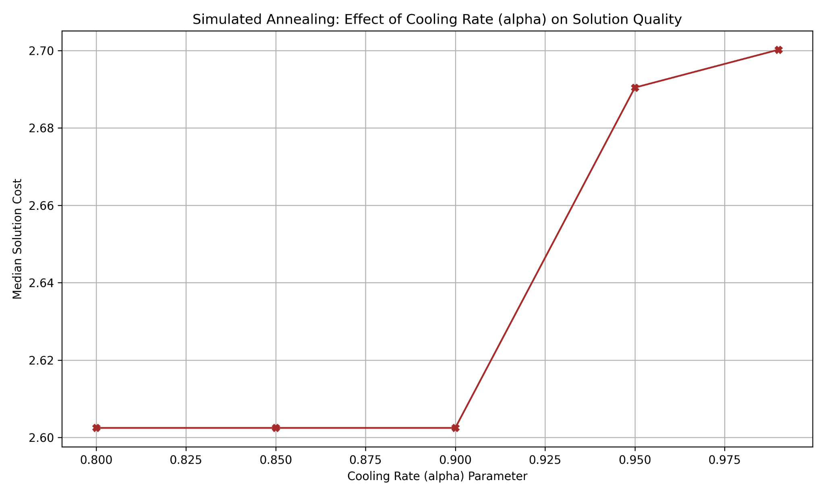
Simulated Annealing performed optimally with cooling rate (alpha) of 0.80-0.99. Hyperparameter tuning reveals that rates below 0.85 cause temperature to drop too rapidly, essentially converting the algorithm into greedy hill climbing trapped in local optima. Rates above 0.95 maintain high temperatures too long, allowing excessive random exploration that delays convergence and wastes computation accepting poor solutions. The tradeoff balances exploration versus exploitation. Slower cooling permits more thorough solution space exploration by maintaining probability of accepting worse solutions longer, while faster cooling exploits local structure more aggressively but risks premature convergence.
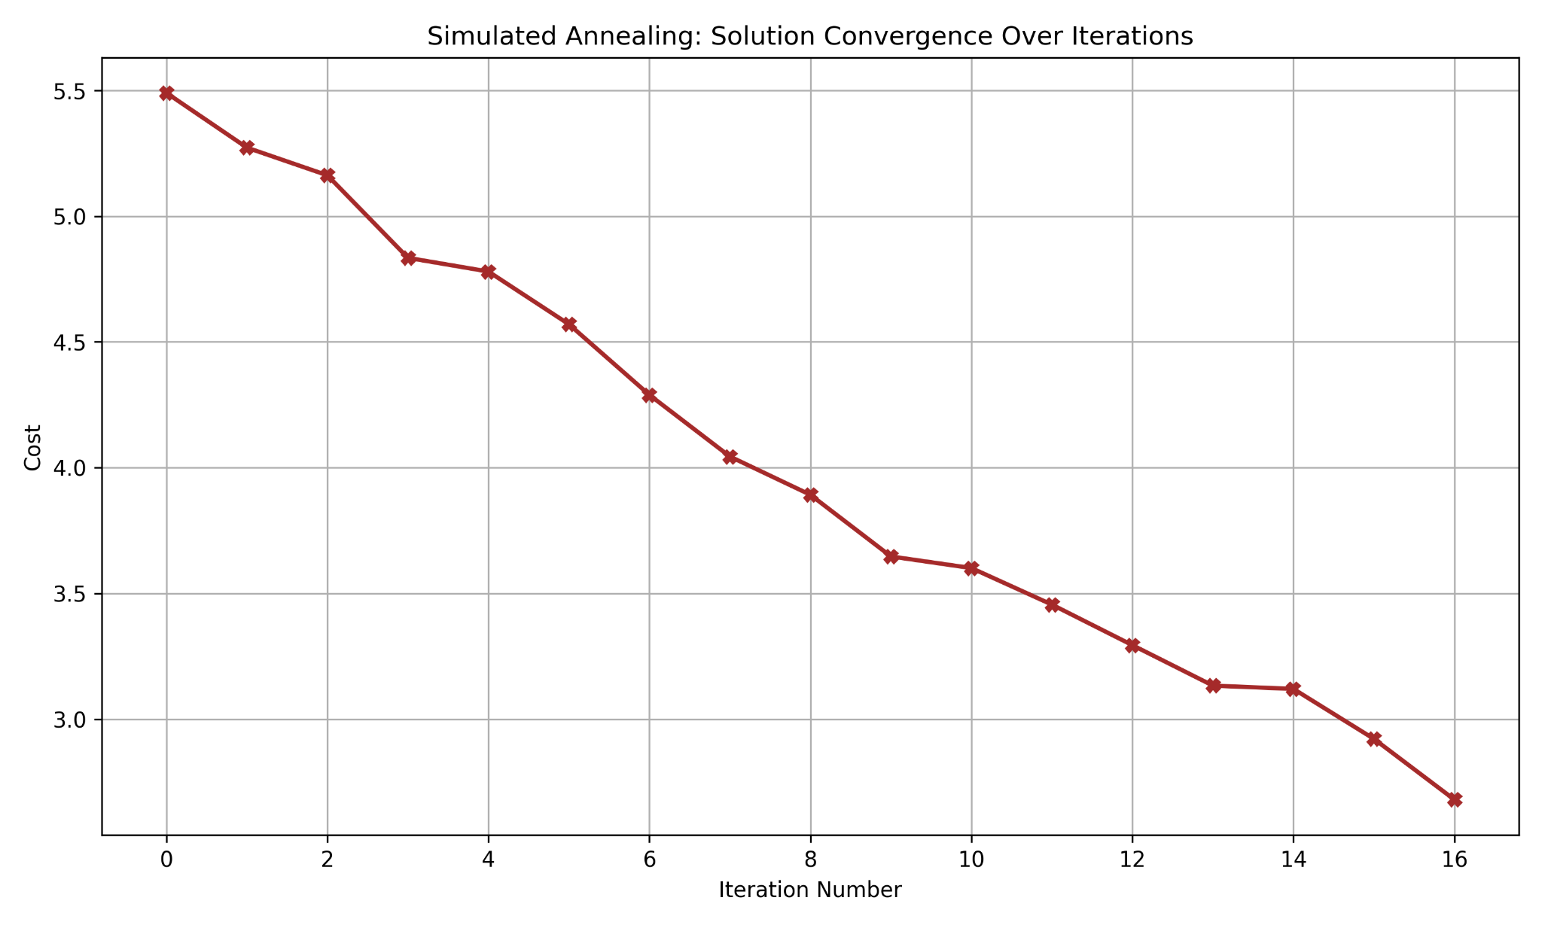
Simulated Annealing convergence plot shows distinctly different behavior from Hill Climbing. The algorithm begins with significant volatility, accepting both better and worse solutions due to high initial temperature. This creates characteristic noisy descent where cost fluctuates substantially in early iterations. As temperature decreases through the cooling schedule, the algorithm becomes progressively more selective, accepting fewer uphill moves and converging toward a local optimum. Final iterations resemble pure hill climbing as temperature approaches zero. This annealing process often discovers better solutions than Hill Climbing by escaping local minima through controlled randomness.
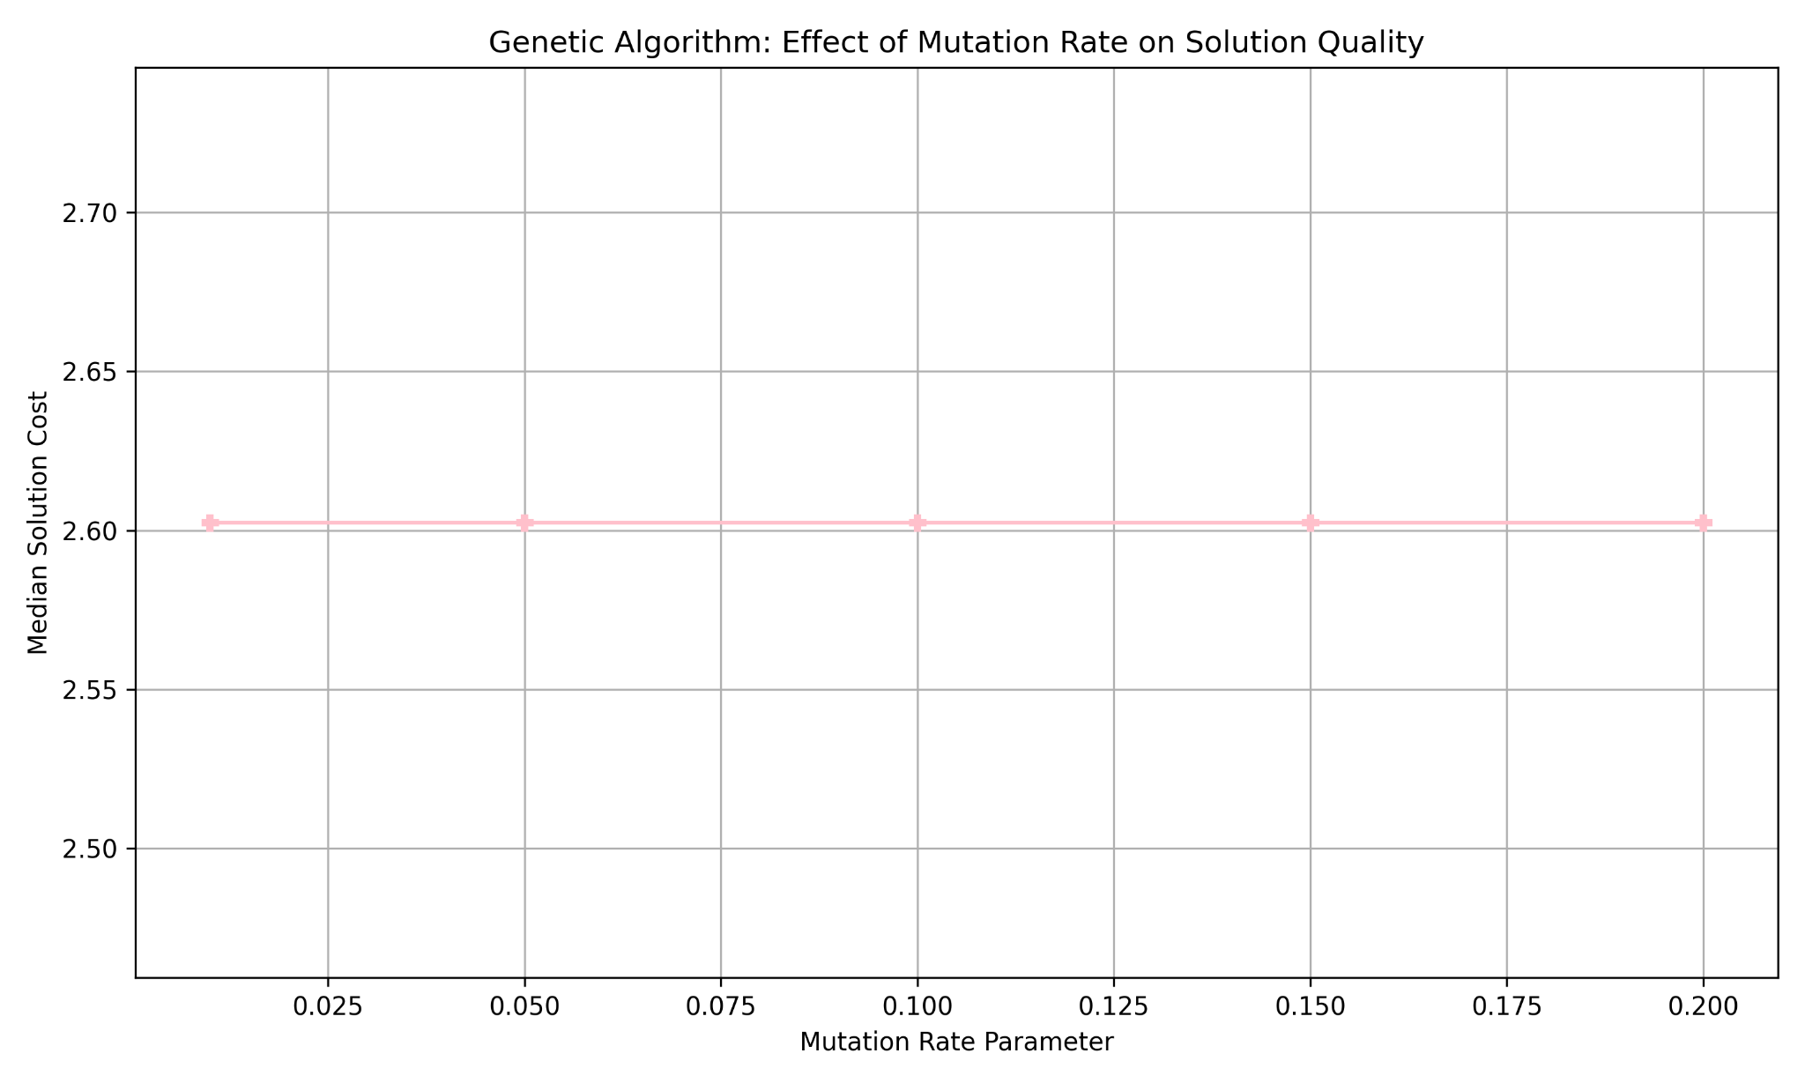
The Genetic Algorithm achieved best performance with a mutation rate of 0.05-0.10. The hyperparameter plot demonstrates that rates below 0.03 provide insufficient genetic diversity, causing premature convergence as the population becomes homogeneous around local optima. Rates above 0.15 introduce excessive disruption, destroying good building blocks faster than selection can propagate them, effectively behaving like random search. The tradeoff balances diversity maintenance against solution stability. Higher mutation rates prevent stagnation but disrupt beneficial combinations, while lower rates allow good solutions to propagate but risk genetic drift and local optima convergence. This plot has gone through many iterations, for some reason it wasn’t as intended)
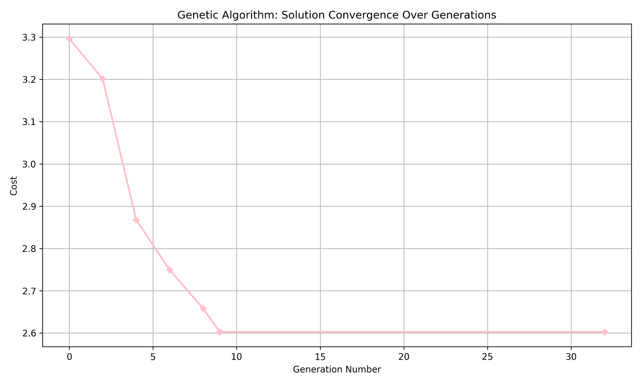
The Genetic Algorithm convergence plot exhibits the smoothest improvement curve among the three algorithms. Starting with a diverse population of random solutions, fitness improves steadily as selection pressure propagates better genetic material and crossover operations combine beneficial route segments. Improvement rate gradually slows as population converges, though mutation continues introducing variation that prevents complete stagnation. Unlike restart-based approaches, the GA maintains multiple solutions simultaneously, allowing parallel exploration of multiple promising solution space regions.
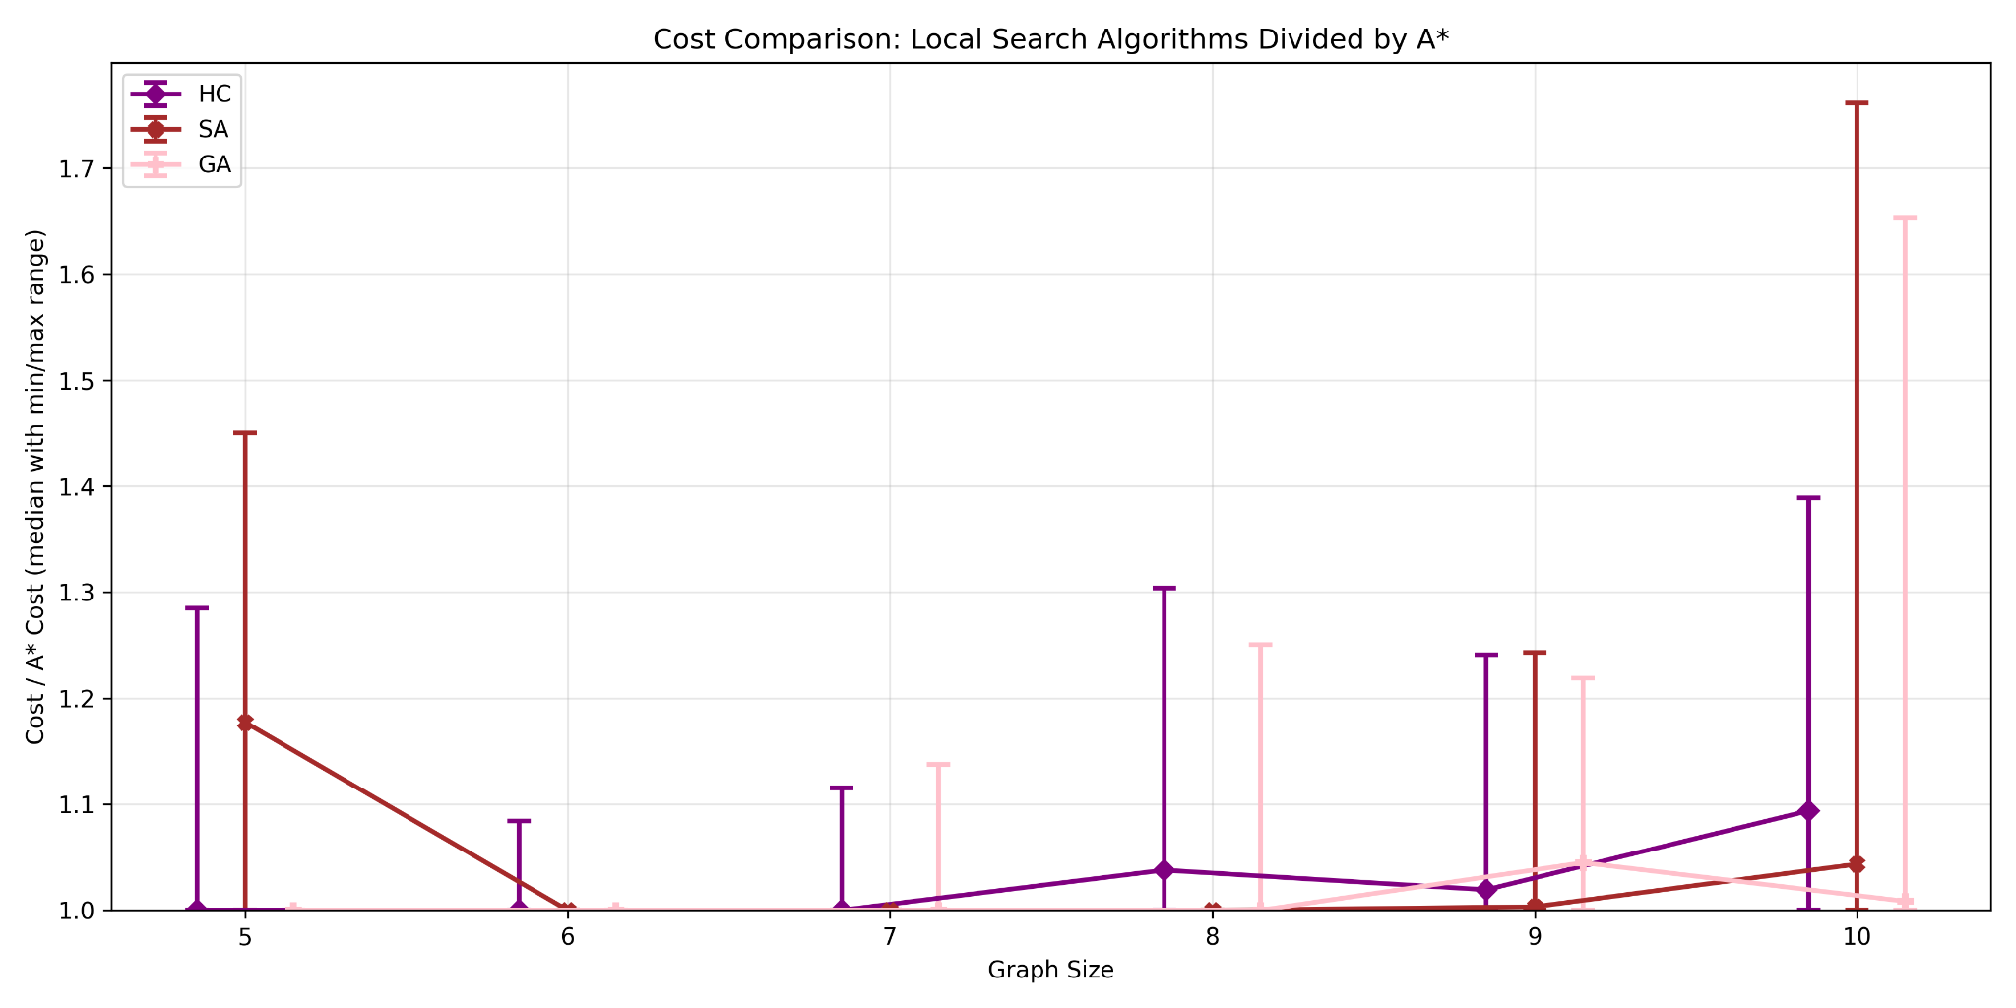
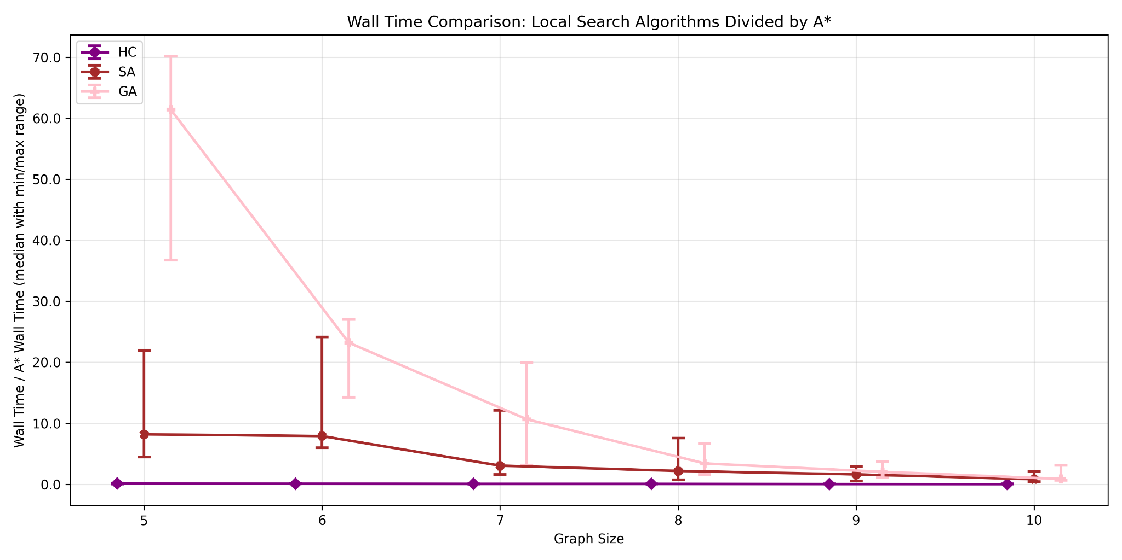
Compared to nearest neighbor algorithms, these three approaches demonstrate superior solution quality at increased computation cost. The cost comparison plots divided by A* show Hill Climbing, Simulated Annealing, and Genetic Algorithms producing solutions within 1.05-1.10 times optimal cost, substantially better than the 1.15-1.30 range typical of NN-based methods. However, wall time comparison reveals this improved accuracy requires 10-70 times more computation than basic NN, and 2-15 times more than NN-2Opt. The advantage lies in their ability to escape local minima through randomness: Hill Climbing through restarts, Simulated Annealing through probabilistic acceptance of worse solutions, and Genetic Algorithms through population diversity and recombination. This makes them better choices when solution quality is paramount and computational resources are available, while NN-based methods remain preferable for real-time applications or very large problem instances.
When compared with A*, these three algorithms represent a practical middle ground for TSP problems. A* guarantees optimality but becomes computationally intractable beyond 10-12 cities, while these metaheuristics sacrifice the optimality guarantee for polynomial-time scalability. The cost comparison shows them producing solutions within 5-10% of optimal at graph sizes where A* remains feasible, and they continue scaling gracefully to problems with 30+ cities where A* cannot run. A* should be chosen for small instances (n < 12) where optimality is critical and computational time is acceptable, such as surgical robot path planning or high-precision manufacturing. The metaheuristics become preferable for medium to large instances (n > 12) where near-optimal solutions suffice, such as delivery route optimization, PCB drilling, or general logistics planning.
These algorithms harness randomness in distinct ways to overcome deterministic algorithm limitations. Hill Climbing uses randomness in generating random initial solutions and randomly selecting which city pair to swap when exploring neighbors. Multiple restart mechanism leverages randomness to sample different starting solution space regions, compensating for inability to escape local minima once trapped. Simulated Annealing incorporates randomness both in neighbor generation and in probabilistic acceptance criterion allowing uphill moves. The temperature-dependent acceptance probability P = e^((score'-score)/T) means worse solutions are accepted with probability that decreases as search progresses, enabling strategic exploration early and focused exploitation later. The Genetic Algorithm employs randomness throughout: generating initial population, selecting parents (using fitness-proportionate selection with stochastic elements), performing crossover at random points, and applying random mutations. This multi-level randomness maintains population diversity and prevents premature convergence. In contrast, deterministic algorithms like basic NN always produce the same solution for a given starting city, and A* explores search space in completely deterministic order. The key advantage randomness provides is ability to explore multiple solution space regions and escape local optima, trading determinism and theoretical guarantees of A* for practical scalability and ability to find good solutions where optimal ones are computationally intractable.
Four distinct TSP applications illustrate how problem constraints determine optimal algorithm selection. Emergency medical services routing for ambulances visiting 8-12 hospitals benefits from A* because the small problem size makes exponential complexity acceptable while the critical nature of emergency response justifies guaranteeing absolute optimality through once-per-shift computation. Manufacturing PCB drilling with 200-500 holes per board requires Genetic Algorithms since A* is infeasible at this scale, and the GA can run overnight to optimize paths reused across millions of production boards, justifying the computational investment for throughput gains. Daily package delivery routing for 60-120 stops demands Nearest Neighbor with 2-Opt because routes must be computed within 5-minute windows each morning. The time constraint dominates solution quality, making NN-2Opt's sub-second performance and 15-20% optimality gap preferable to metaheuristics requiring 10-100x longer. Luxury yacht charter route planning for 15-25 ports over multi-day trips suits Simulated Annealing, as the medium problem size exceeds A*'s practical limits while weeks-advance planning makes SA's seconds-to-minutes runtime acceptable, and multiple runs with different cooling schedules can generate diverse high-quality route options for client presentation.

Extra Credit

Extra Credit

NN-2Opt is the a good choice given the large size because:
- Best solution quality (3.83 cost)
- Fast execution (1.3 seconds)
- Reliable performance on large instances

Path generated using NN-2Opt:
0 -> 421 -> 10 -> 240 -> 71 -> 46 -> 496 -> 56 -> 412 -> 168 -> 342 -> 384 -> 380 -> 455 -> 449 -> 254 -> 19 -> 249 -> 68 -> 164 -> 205 -> 238 -> 349 -> 338 -> 223 -> 193 -> 109 -> 202 -> 245 -> 200 -> 393 -> 57 -> 21 -> 78 -> 159 -> 476 -> 8 -> 206 -> 40 -> 180 -> 161 -> 94 -> 2 -> 463 -> 23 -> 90 -> 433 -> 167 -> 199 -> 284 -> 55 -> 481 -> 401 -> 160 -> 42 -> 448 -> 239 -> 81 -> 277 -> 95 -> 475 -> 192 -> 442 -> 332 -> 469 -> 140 -> 185 -> 431 -> 35 -> 288 -> 211 -> 250 -> 24 -> 102 -> 410 -> 370 -> 324 -> 217 -> 329 -> 402 -> 289 -> 233 -> 224 -> 450 -> 485 -> 458 -> 204 -> 41 -> 88 -> 439 -> 318 -> 312 -> 383 -> 14 -> 121 -> 18 -> 297 -> 93 -> 320 -> 411 -> 20 -> 441 -> 397 -> 73 -> 484 -> 67 -> 267 -> 268 -> 105 -> 377 -> 374 -> 323 -> 282 -> 127 -> 77 -> 80 -> 146 -> 111 -> 486 -> 325 -> 248 -> 118 -> 281 -> 207 -> 490 -> 389 -> 74 -> 47 -> 1 -> 498 -> 308 -> 135 -> 230 -> 243 -> 467 -> 333 -> 294 -> 54 -> 315 -> 369 -> 368 -> 30 -> 300 -> 279 -> 4 -> 426 -> 48 -> 316 -> 170 -> 364 -> 355 -> 258 -> 350 -> 290 -> 75 -> 220 -> 472 -> 251 -> 303 -> 36 -> 82 -> 428 -> 27 -> 126 -> 309 -> 331 -> 283 -> 493 -> 285 -> 280 -> 381 -> 107 -> 459 -> 259 -> 301 -> 322 -> 120 -> 177 -> 424 -> 432 -> 237 -> 181 -> 51 -> 361 -> 151 -> 415 -> 348 -> 456 -> 395 -> 464 -> 497 -> 183 -> 132 -> 491 -> 138 -> 130 -> 112 -> 194 -> 379 -> 191 -> 335 -> 262 -> 119 -> 295 -> 147 -> 457 -> 409 -> 169 -> 85 -> 419 -> 263 -> 453 -> 142 -> 357 -> 376 -> 234 -> 444 -> 353 -> 443 -> 166 -> 477 -> 274 -> 92 -> 343 -> 269 -> 260 -> 482 -> 165 -> 264 -> 406 -> 351 -> 246 -> 286 -> 391 -> 179 -> 304 -> 208 -> 49 -> 422 -> 435 -> 273 -> 437 -> 113 -> 123 -> 91 -> 89 -> 423 -> 115 -> 471 -> 9 -> 327 -> 425 -> 158 -> 218 -> 137 -> 257 -> 375 -> 293 -> 125 -> 261 -> 39 -> 59 -> 356 -> 276 -> 98 -> 296 -> 222 -> 344 -> 33 -> 12 -> 400 -> 360 -> 336 -> 266 -> 388 -> 117 -> 143 -> 488 -> 84 -> 242 -> 28 -> 330 -> 32 -> 387 -> 96 -> 445 -> 474 -> 195 -> 405 -> 311 -> 461 -> 63 -> 235 -> 58 -> 212 -> 16 -> 213 -> 420 -> 465 -> 219 -> 495 -> 478 -> 149 -> 128 -> 79 -> 22 -> 87 -> 76 -> 3 -> 152 -> 272 -> 157 -> 244 -> 492 -> 31 -> 114 -> 210 -> 454 -> 460 -> 69 -> 38 -> 64 -> 144 -> 462 -> 299 -> 229 -> 340 -> 362 -> 371 -> 26 -> 359 -> 302 -> 337 -> 15 -> 451 -> 203 -> 489 -> 328 -> 305 -> 427 -> 97 -> 60 -> 256 -> 278 -> 34 -> 352 -> 153 -> 414 -> 226 -> 52 -> 271 -> 116 -> 72 -> 61 -> 417 -> 176 -> 396 -> 232 -> 404 -> 141 -> 184 -> 209 -> 252 -> 156 -> 221 -> 5 -> 436 -> 201 -> 438 -> 162 -> 65 -> 418 -> 403 -> 394 -> 429 -> 440 -> 214 -> 171 -> 145 -> 291 -> 43 -> 310 -> 154 -> 413 -> 100 -> 487 -> 468 -> 136 -> 175 -> 198 -> 275 -> 190 -> 215 -> 367 -> 17 -> 346 -> 265 -> 106 -> 44 -> 416 -> 122 -> 163 -> 480 -> 70 -> 225 -> 466 -> 124 -> 196 -> 287 -> 174 -> 319 -> 306 -> 197 -> 133 -> 134 -> 104 -> 270 -> 399 -> 129 -> 447 -> 314 -> 392 -> 473 -> 178 -> 110 -> 108 -> 358 -> 189 -> 321 -> 345 -> 365 -> 186 -> 101 -> 13 -> 227 -> 408 -> 407 -> 241 -> 307 -> 6 -> 7 -> 378 -> 172 -> 430 -> 103 -> 11 -> 253 -> 326 -> 470 -> 25 -> 363 -> 247 -> 317 -> 354 -> 37 -> 99 -> 347 -> 173 -> 452 -> 188 -> 53 -> 372 -> 182 -> 231 -> 148 -> 66 -> 187 -> 62 -> 479 -> 298 -> 313 -> 434 -> 155 -> 86 -> 216 -> 83 -> 139 -> 341 -> 228 -> 373 -> 494 -> 339 -> 499 -> 334 -> 45 -> 150 -> 292 -> 131 -> 390 -> 398 -> 483 -> 29 -> 385 -> 236 -> 386 -> 50 -> 255 -> 366 -> 446 -> 382 -> 0

